|  |  |
| --- | --- |
| **Name:** | |
| **School:** | |
| **Class:** | |
| **QTY** | |
| **Space, Stars and Slimy Aliens**  **40 AED** |  |
| **Shocking Electricity**  **40 AED** |  |
| **Blood, Bones and Body Bits**  **40AED** |  |
|  | **TOTAL** |

Please bring your money in on the day and ask Nick to sign your book.

Have a great visit full of Horrible Science!

**Dear Parent / Guardian**

On………………… we are delighted to welcome leading UK children’s author Nick Arnold, to give a presentation.

A selection of Nick’s books will be available to buy. Nick will sign all book purchased on the day.

**About Nick Arnold Author & Book Order Form**

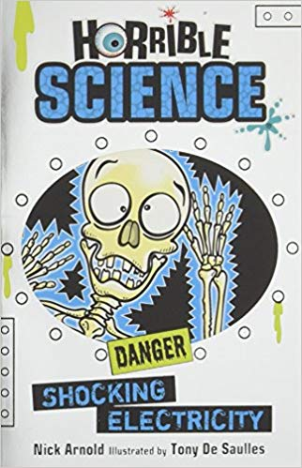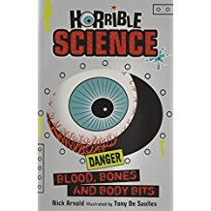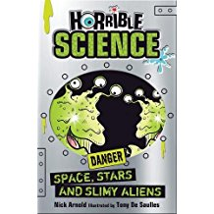

**Shocking Electricity** - Horrible Science: Shocking Electricity is packed with sizzling zap-filled facts to electrify every reader. Children can find out about the scientist who gave electric shocks to his eyeballs, that lightning can strike you with heat five times hotter than the sun and much more besides!

**Blood, Bones and Body Bits -** is bone-chilling book of bodies to make kids squeal! Find out what happens when a boil bursts. See what lives in your eyelashes. Gulp at the workings of your disgusting digestion. And discover why corpses need haircuts even after they're dead. This book of squishy, squelchy and amazing things lets children get the inside story on their insides - if they dare!

**Space, Stars and Slimy Aliens -** Science with the squishy bits left in! Why does space make the guts explode? Which astronomers killed people? What does the moon smell like? Get the awful answers in Space, Stars and Slimy Aliens!

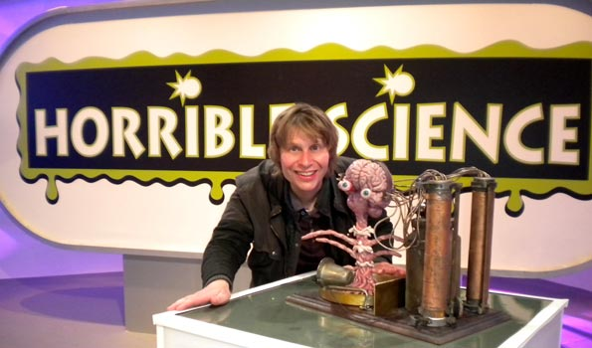

Nick isn’t just a human being he’s a one-person book factory who (when he’s not penning bestsellers) gets up to all sorts of tricks to show everyone that books are really the most wonderful invention since inventions were invented. Oh yes, and when he’s not acting crazy about science, he’s crazy about history instead!

Nick is the author of the award winning Horrible Science and Wild Lives series, which are on sale in over 40 countries.

